Sentiment Analysis for Chandrayaan 2

Rohan Seam
Department of Computer Science
University of Washington
rseam@uw.edu

Abstract— My goal is to be able to build a generative model using a convolutional neural network that determines sentiment towards the recent Indian moon mission, Chandrayaan 2. Previous work has looked at sentiment of topics that are not directly related to this mission. There have been numerous other researchers that have used convolution neural networks to predict sentiment, but not regarding Chandrayaan 2. My approach focuses on using a convolutional neural network to predict sentiment of Twitter tweets [1] regarding this mission.

Introduction
Predicting attitude and/or opinion regarding a specific topic is always a difficult task. Most people can generally predict someone’s opinion about a certain topic, but can we simulate this using a computer? The difficulties with this approach are that it can be complicated to try and determine opinions and attitude of a tweet without having much context or body language to refer to. Some of the limitations to this case study is that I am limited to predicting sentiment of this topic based on Twitter users that tweeted about Chandrayaan 2.

Background
One example of previous work using convolutional neural networks to come up with predictions about a specific topic was written by Sezerer et al [2]. This focused on using Twitter tweets to predict the gender of the user which differs in purpose compared to my project. One of the main objectives of my project is to be able to correctly identify positive or negative sentiment while also creating a model that is capable of learning long-term structure and correctly identify new tweets that may arrive later. The problem with Sezerer’s work is that we can see how many assumptions are made, based on patterns, in order to determine the gender of a Twitter user based on their choice of words in their tweets. In my project, I tackle the idea of predicting sentiment without making too many assumptions, but rather training based on patterns in data.

Problem statement
The idea of using a convolutional neural network to predict sentiment of Chandrayaan 2 was significant to me because this mission occurred just days before starting this project. My goal is to be able to successfully analyze Twitter tweets regarding this topic and provide sentiment for each tweet. This will then allow me to get a consensus of the overall sentiment of the mission.

Technical details

Dataset
In order to train my model, it is very important to have Twitter tweets that provide information of Chandrayaan 2. To be able to do this, I wrote a python script that uses tweepy [3] to extract tweets from Twitter using a Twitter developer account. The format of the raw data is one tweet per line with a tweet number prepended to the tweet. This is then saved to a text file for cleaning and processing.

Model / Implementation Details
- The first step in order to create my models was to clean the extracted tweets of non-alphabetical words, links, Twitter handles, etc. In order to do this, I wrote a short python script that parsed through all the extracted tweets and wrote the clean versions to a new text file to be used later. After this, I wrote another script using nltk [4] to separate my tweets into positive and negative text files by finding a polarity score of each tweet and separating by positive if the polarity score is greater than 0.5 and negative if less than -0.1. I then decided to separate my tweets to have 80% of them used as training and 20% used as testing.
- The next part is to create our vocabulary which is essentially just words that are unique within my dataset. I did this by creating a script that iterated over the training files for positive and negative tweets and saved the unique words in a new text document with one word on each line.
- Now that I created the vocabulary, I can create a multilayer perceptron Bag of Word model (MLP). I did this by writing a script to use the vocabulary, and negative and positive training tweets to create the model.
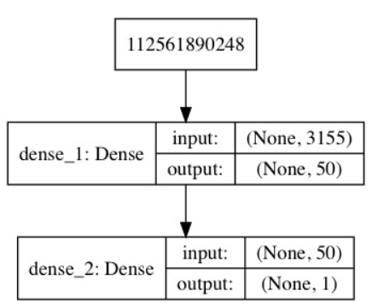
Figure 1: Plot of defined Bag of Words model

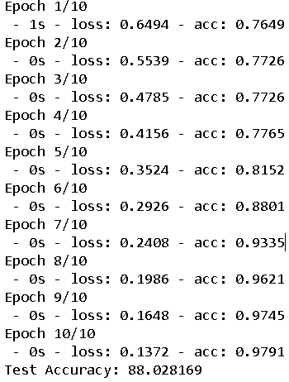
Figure 2: Output of training and evaluating MLP model
As we can see from Figure 2, the training data fits within 10 epochs and achieves an accuracy of approximately 88%. We can also see that the accuracy increases each time close to 100% using 10-fold cross validation.
- The next step is to now use the Keras [5] API to determine the four different methods to score words including binary, count, tfidf, and freq. I used the four scoring modes and generated accuracy for each one.

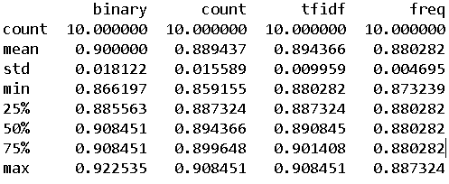
Figure 3: Output of model comparing four encoding schemes.
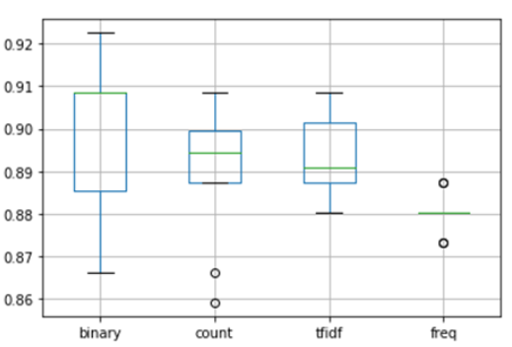
Figure 4: Boxplot comparing encoding schemes for my model.
As we can see from Figure 3 and Figure 4, the binary encoding scheme achieved the best accuracy and will most likely be the preferred approach for my dataset. In Figure 4, we can see that the binary plot has the furthest spread which further reinforced the idea that binary is the best option moving forward. I then used this model to predict sentiment of my test tweets and saved results of each tweet to a text file.
- I then moved onto training a CNN with an embedding layer. In this approach each word in my vocabulary is represented by a real valued vector in a high-dimensional space. This differs from my previous Bag of Words approach since in a Bag of Words representation, we either ignore relationships between words or use a bigram or trigram approach. Using a 100-dimensional vector space, I was able to generate the following model.
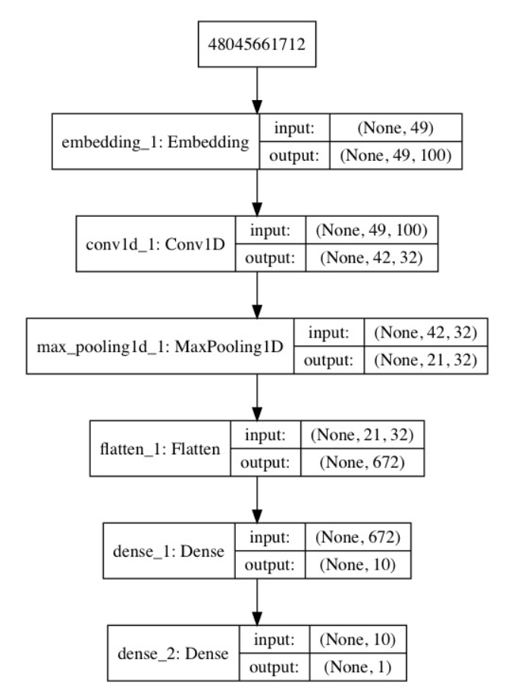
Figure 5: Output of CNN classification model.
We can see from Figure 5 that the embedding layer expects documents with length of 49 words as input and encodes each word in the document as a 100-element vector. After fitting the network on the training data, I used a binary cross entropy loss function since this is a binary classification problem. I once again trained the model for 10 epochs and achieved the following.
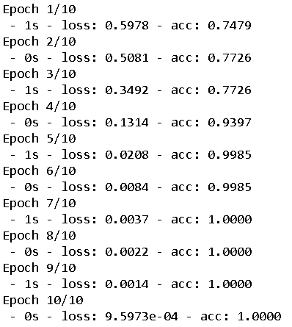
Figure 6: Output from fitting the model through 10 epochs.
We can see from Figure 6 that the accuracy quickly increases after each pass and reaches a peak accuracy of 100. After using this model and running on testing tweets, I achieved a train accuracy of 96.37% and test accuracy of 81.12%.
- The final part was to develop an n-gram CNN model for sentiment analysis of Chandrayaan 2. This expands the previous model by using multiple parallel convolutional neural networks. This multi-level network differs from the previous because it can process documents at different resolutions or different n-grams at a time. Generating and fitting the model produces the following output.
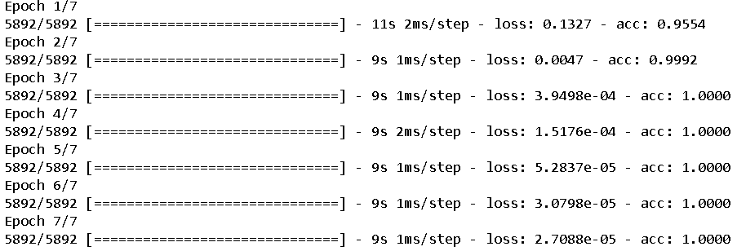
Figure 7: Output from fitting the model
We can easily see that with this model, only after 7 epochs, we are able to achieve a high accuracy fairly quickly. If we compare this to the previous model, we can see this model shows good skill on the training database whereas the previous achieves high accuracy after 10 epochs.
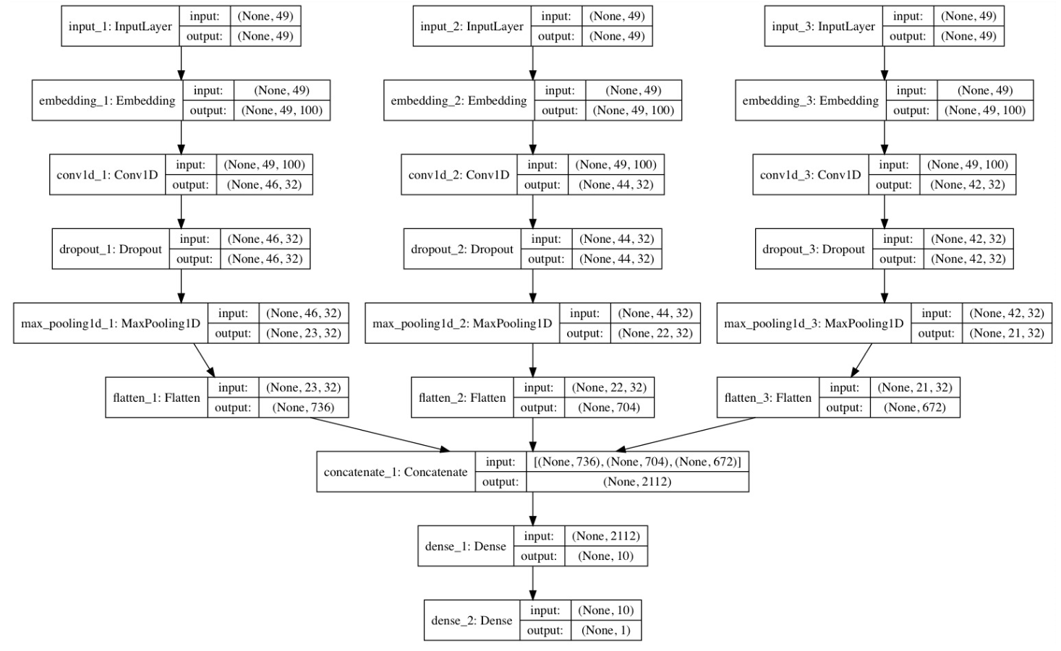
Figure 8: Plot of multichannel Convolutional Neural Network
We can see from Figure 8, the three channels as input into the model.After this, I once again ran this model on my testing tweets and received a train accuracy of 76.88 and a test accuracy of 76.22. I generated sentiment on my testing tweets and got mostly positive sentiment overall.

Conclusion & Future Steps
Throughout this project, I was able to apply my knowledge of neural networks and bag of words representation to generate sentiment about the Chandrayaan 2 moon mission on Twitter tweets extracted using Python. I was able to generate three different sentiment files and confirm the output based on the tweet’s original content. In the future I would like to improve my accuracy on the multichannel model. I noticed that the training accuracy was only 76.88%, which is quite low. This may be improved by having more tweets as my model would perform better with more data to train it. I would start with 50,000 tweets next time as a start instead of just 20,000.

References
- “Developer - Twitter Developers.” Twitter, Twitter, https://dev.twitter.com/.
- Sezerer, Erhan & Polatbilek, Ozan & Sevgili, Özge & Tekir, Selma. (2018). Gender Prediction From Tweets With Convolutional Neural Networks. K. Elissa, “Title of paper if known,” unpublished.
- Roesslein, Joshua. "Tweepy." Python programming language module (2015).
- Loper, Edward, and Steven Bird. "NLTK: the natural language toolkit." arXiv preprint cs/0205028 (2002)..
- Chollet, François. "Keras." (2015).

